**Name: merin joseph**

**Roll No:20**

**Batch:MCA-B**

**Date:21-03-2022**

**NETWORKING & SYSTEM ADMINISTRATION LAB**

**Experiment No.: 1**

**Aim**

Install the latest version of Ubuntu on an Oracle VM VirtualBox.

**Procedure**

Below are the very easy steps with screenshots containing the installation procedure of Virtual Box.

**Output Screenshot**

Step 1:clicknext

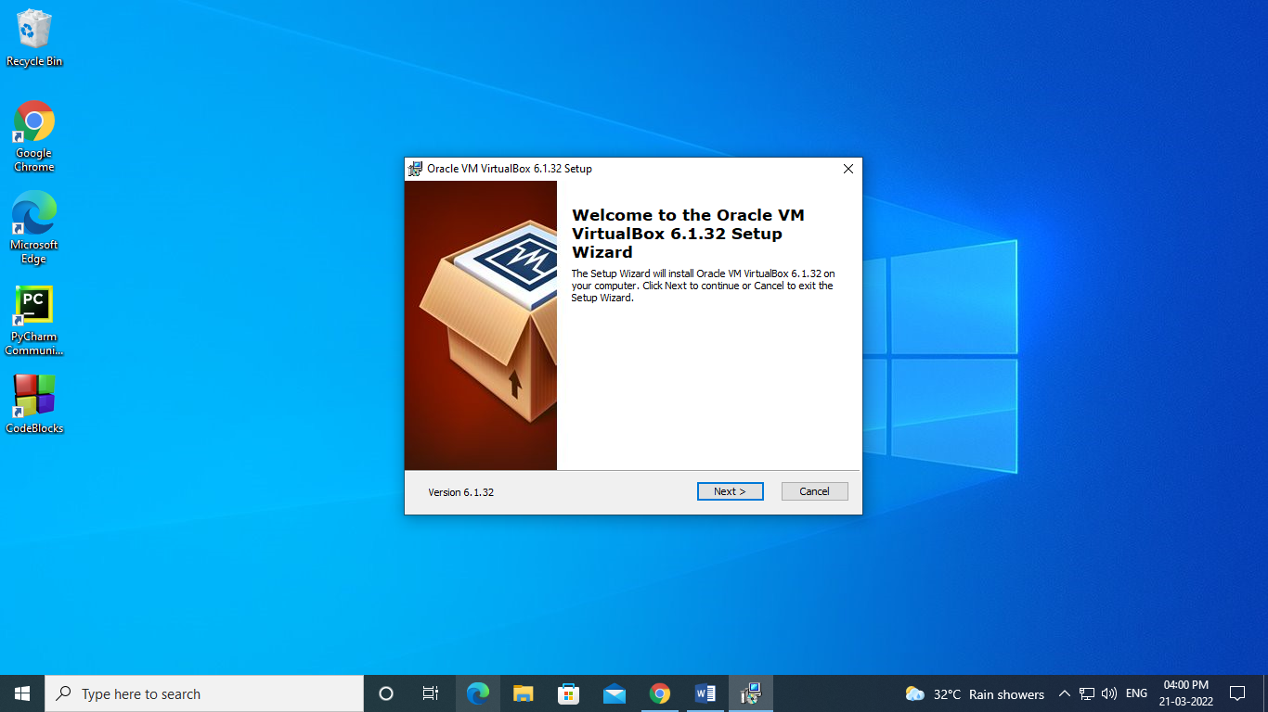

Step 2:clicknext

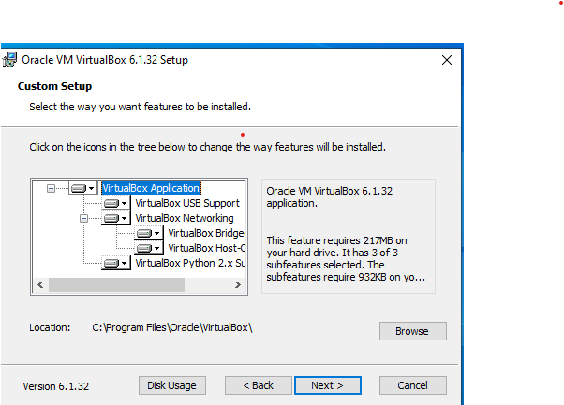

Step 3:click next

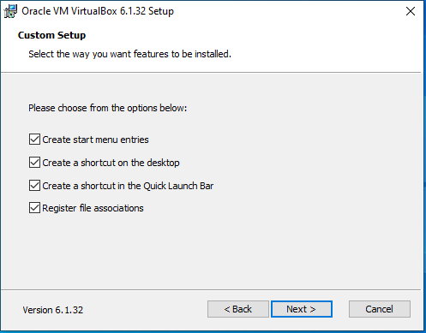

Step4:click yes

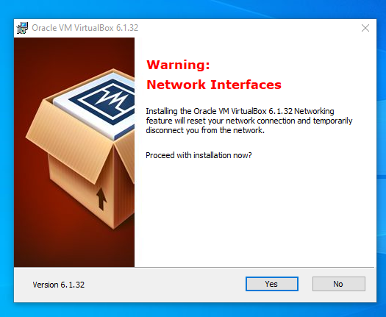

Step 5:click install

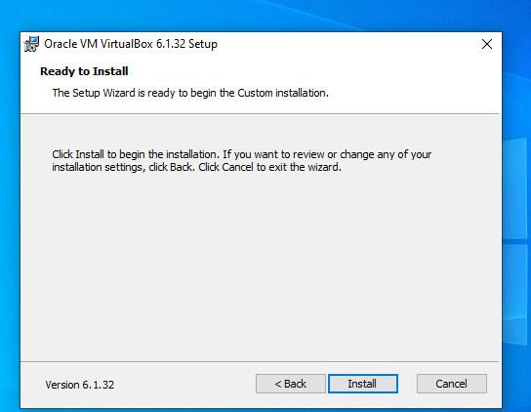

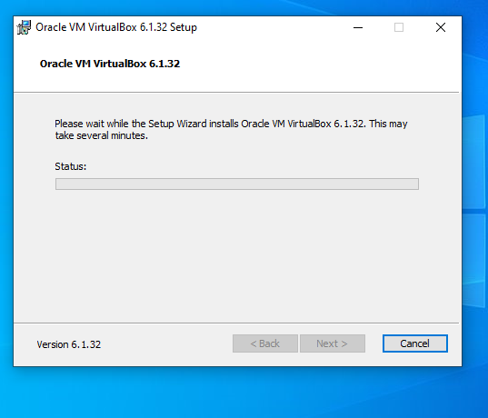

Step 6:install

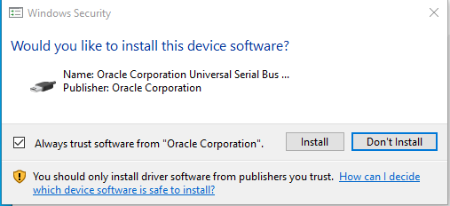

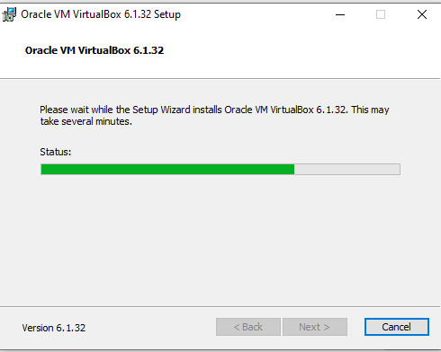

Step 7:finish

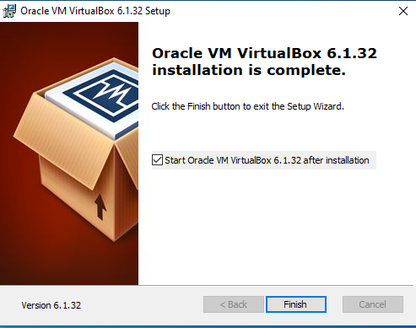

### Step8: Click on “New” to create a virtual machine

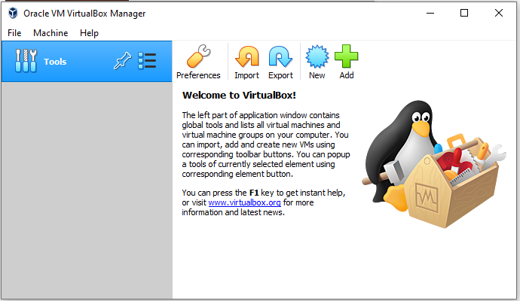

### Step 9: Enter Name for your Virtual Machine

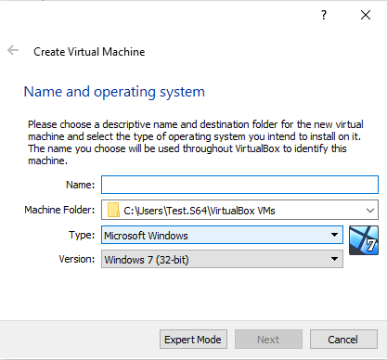

### Step10: Enter amount of memory (RAM) =1024 MB and click “Next”

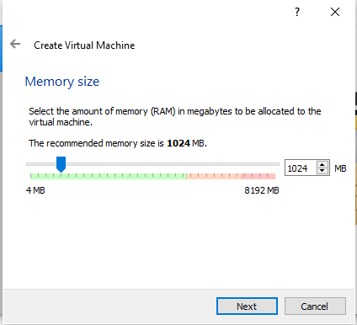

### Step11: Click “Create” to create hard drive

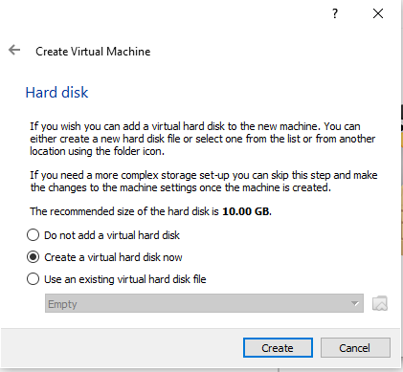

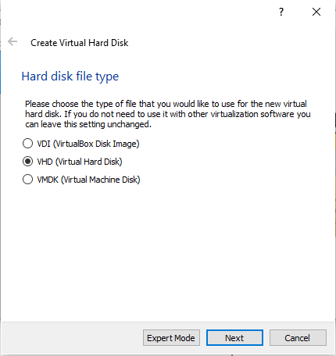

Step 12:click next

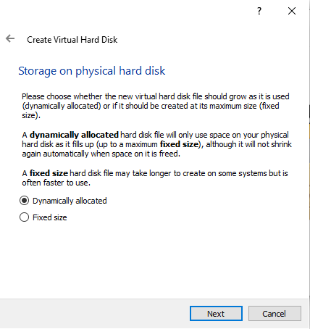

### Step13: Enter Size of Virtual Hard Drive= 20 GB and Click “Create”

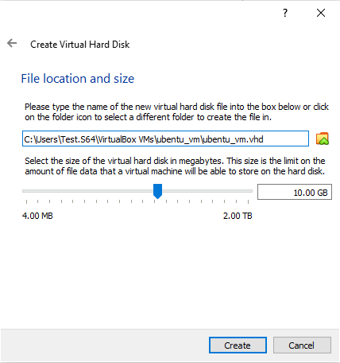

### Step14: Select Virtual Machine

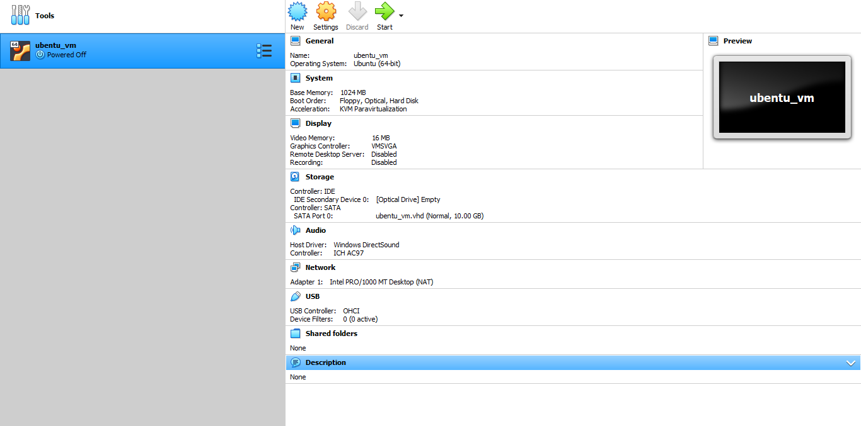

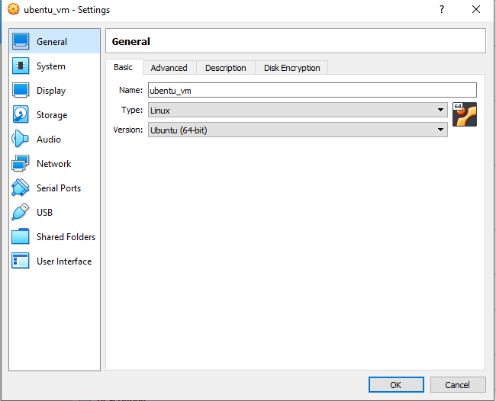

### Step15: Click “Install Ubuntu”

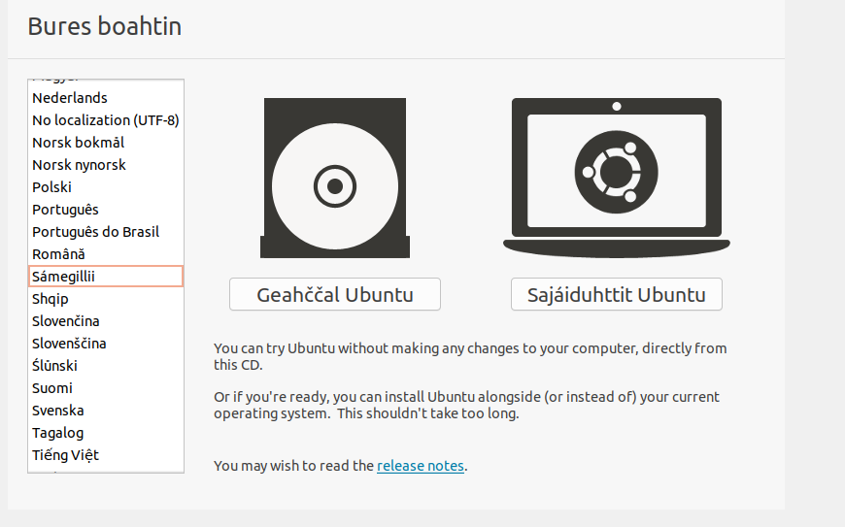

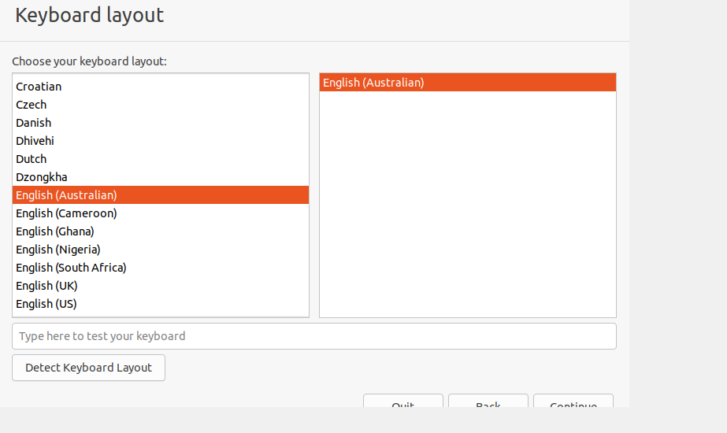

### Step16: Click “Continue”

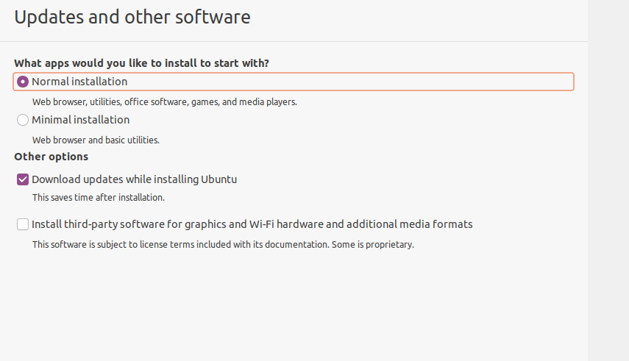

### Step17: Select location and click “Continue”

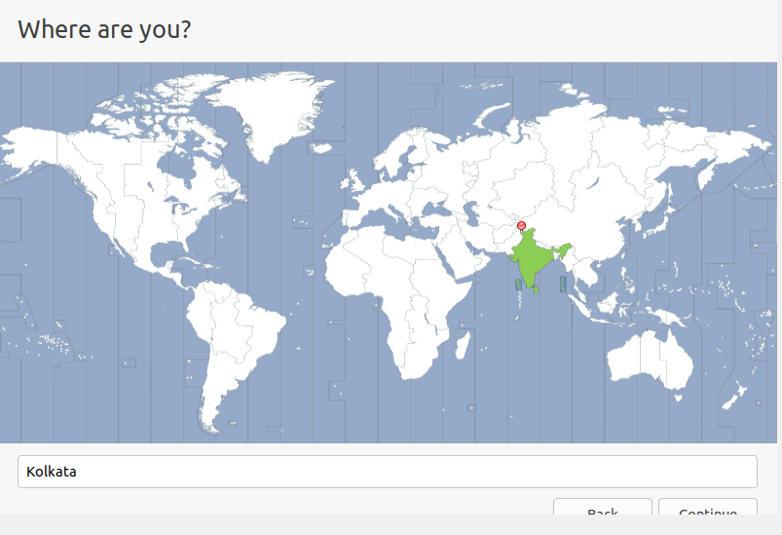

### Step18: Fill all the details and Click “Continue”

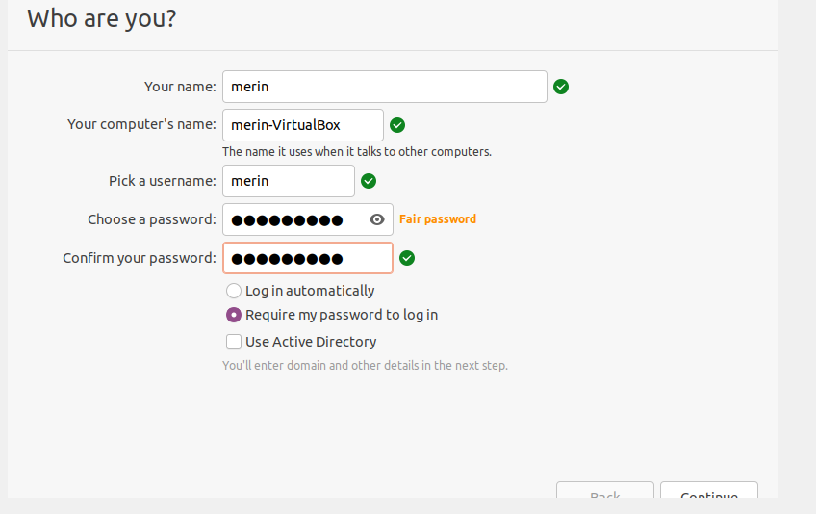

### Step19:  Now the installation process will start and installation window will appear

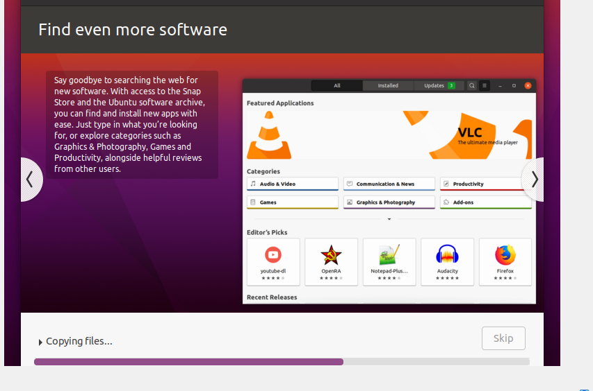

### Step20:  Click “Restart Now”

